GO Reporting Project-Release 2

Feasibility Report- Actual Cost of Exploded BOM

**Version:** 1.0

**Last Revision Date: June** 25, 2019

**Print Date:**

Table of Contents

1 Objective 2

1.1 Requirement of Actual Cost by Exploded BOM as per SOR 2

1.1.1 In-scope Items: 3

1.1.2 Get Custom development (RICEFWs) 3

1.1.3 Create New Follow up items 3

1.1.4 Exclusions / Out of Scope 3

1.1.5 Assumptions 3

1.2 SAP OSS Notes 3

1.3 Tate & Lyle OSS Incident 7

1.4 Feasibility Analysis 9

1.4.1 CKM3N-Cost Roll Up is not possible 9

1.4.2 Z Report Actual Cost Display 10

1.5 Conclusion 11

1.6 Assumption 11

# Objective

Tate & Lyle as a part of its strategic journey to achieve excellence in business processes and capabilities, one of their objectives is to continue to improve Global Operations (GO) Reporting and Forecasting because there is a need to align the lens with which Global Operations views costs with that of commercial business units.

Furthermore, the plants need additional granularity to describe which product/product families are driving the variances and at what area or cost component. As a next step, Global Operations would like to achieve further drilldown and granular reporting to provide price and usage variance analysis.

The objective of this document is to state the feasibility of developing Z report in SAP ECC on Actual Cost by Exploded BOM

## Requirement of Actual Cost by Exploded BOM as per SOR

### In-scope Items:

In SAP ECC Z Report for Actual Cost by Exploded BOM required to be developed. Z report must have Actual cost of exploded BOM at each component levels.

Required Report Columns:

* + - * Master data (Example Company Code, Plant, Currency, Fiscal Year, Posting Period, Cost Center & Etc.,)
      * Thirteen Variable Cost Components
      * Four Fixed Cost Components
      * BOM Quantity, Actual Price, Actual Value, Total Cost

BOM Valuation of Single and Multilevel must be done at actual cost with the break -up of individual components and roll up the cost to header level for each BOM components.

### Get Custom development (RICEFWs)

* In SAP ECC – Z Report required for Actual Cost of Exploded BOM
* Security role Plant Finance to be assigned to Z Report

### Create New Follow up items

* Scrap treatment to be discussed with Business

### Exclusions / Out of Scope

Not Applicable

### Assumptions

* Any Cost other than BOM components cost shall be ignored.
* Inter Company stock transfer cost is valuated at Actual Cost (No mark up or intercompany profit elimination is needed in the Z Report)

## SAP OSS Notes

SAP Note- 1884961

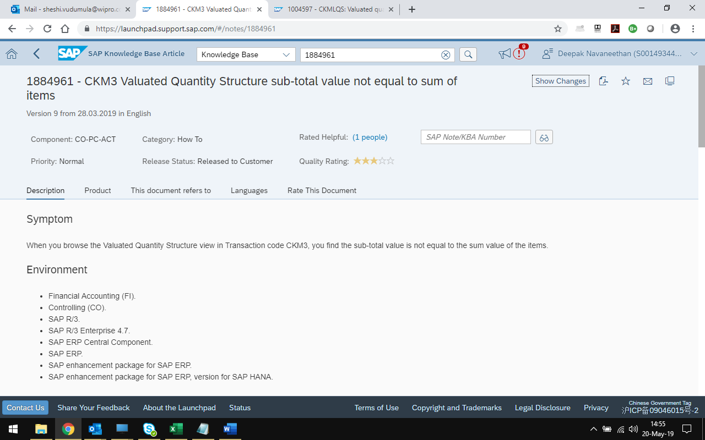

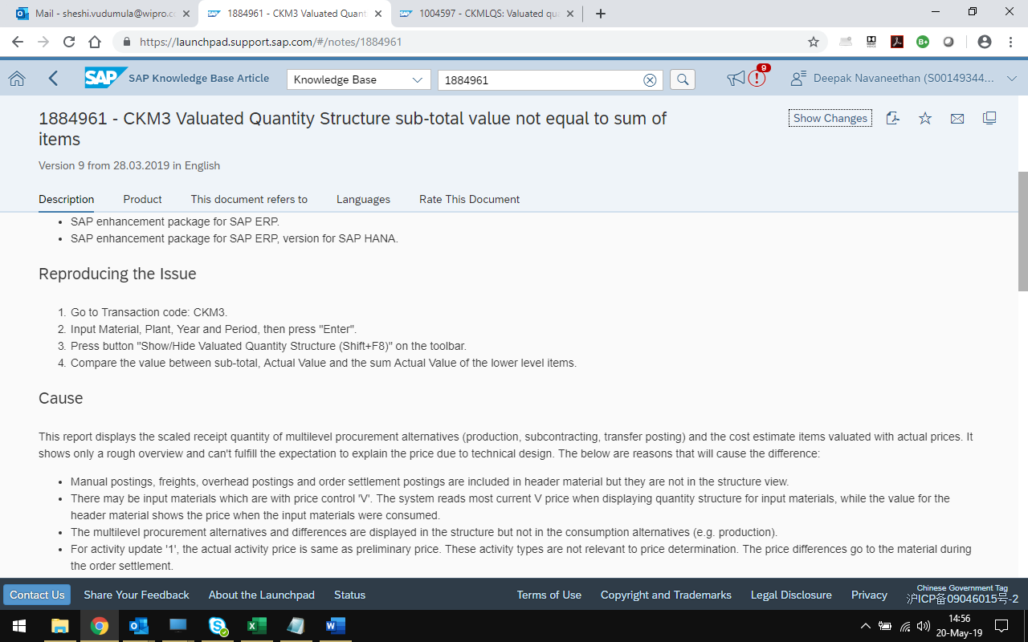

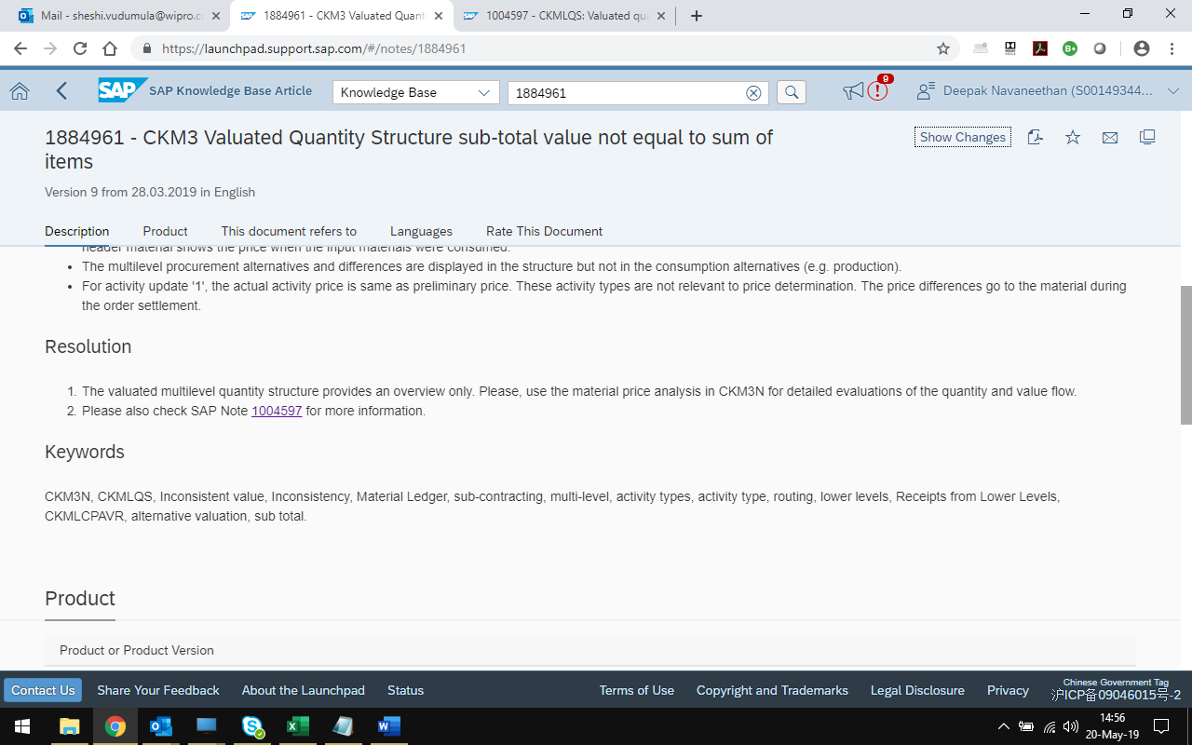

SAP Note- 1004597

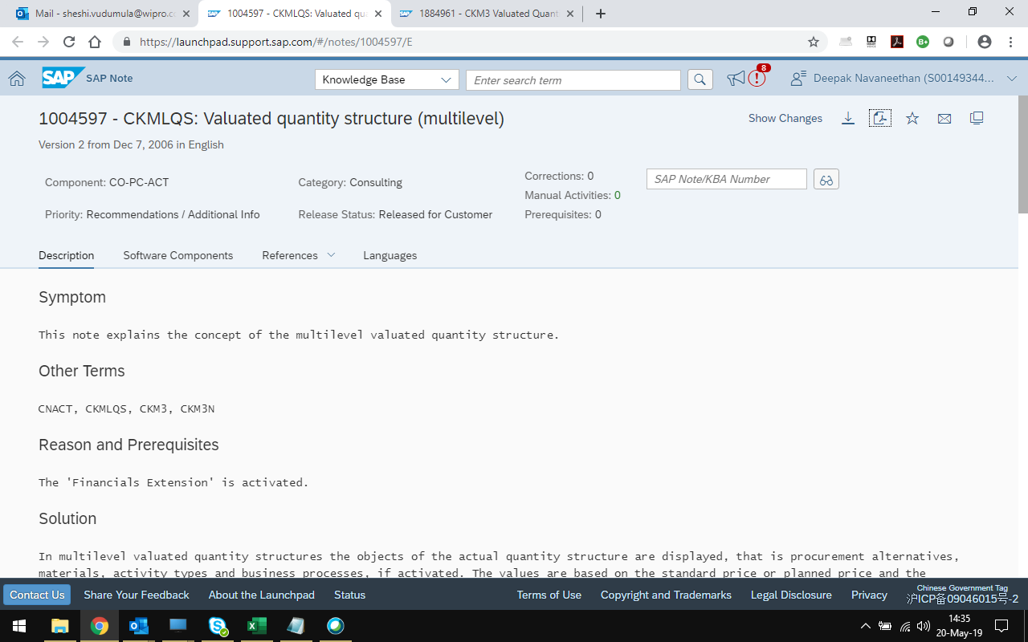

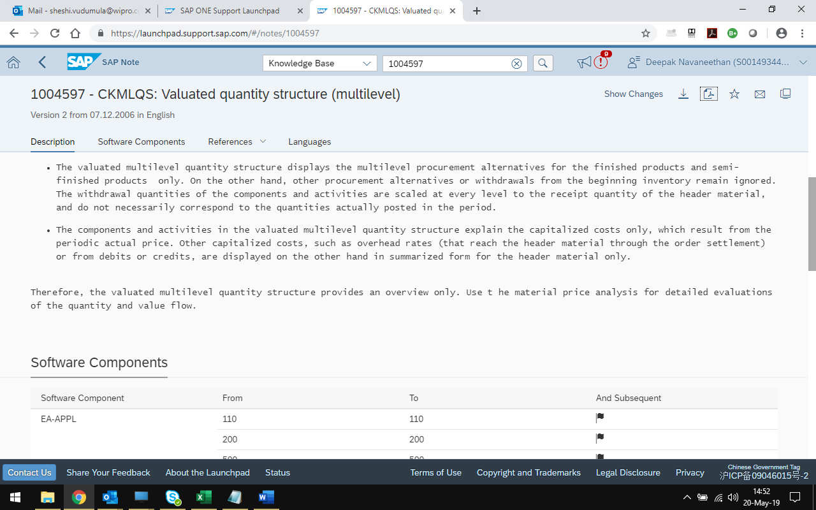

## Tate & Lyle OSS Incident

Incident Number 311027/2019 Actual Cost of Exploded BOM

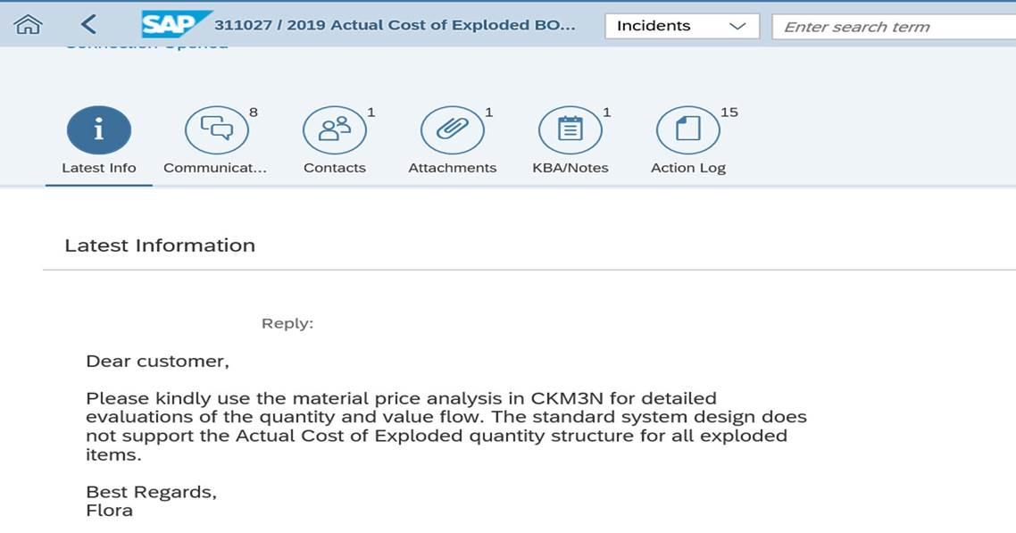

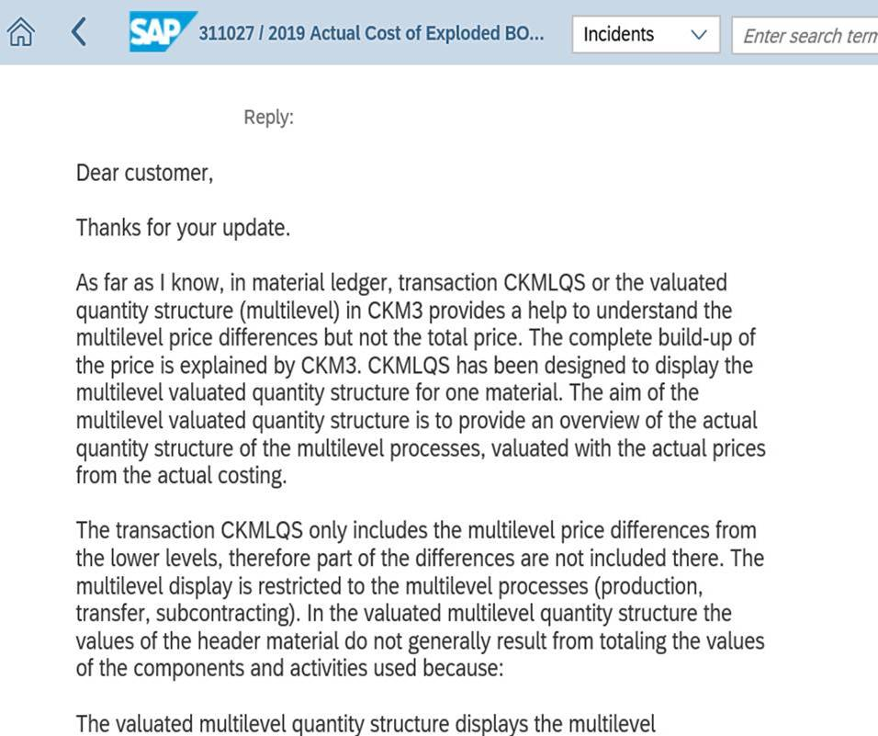

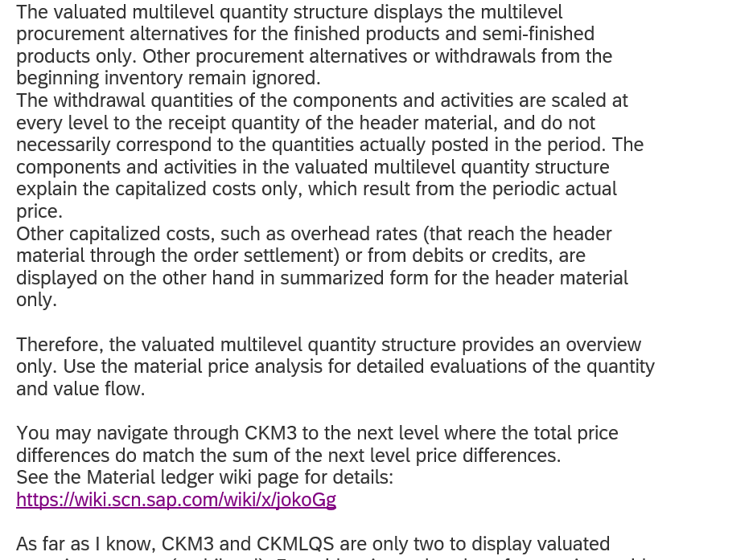

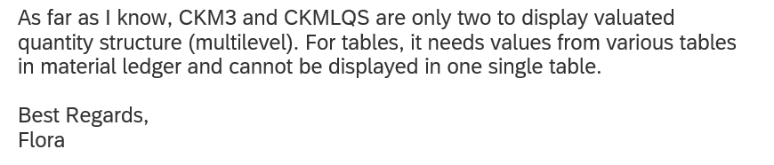

## Feasibility Analysis

### CKM3N-Cost Roll Up is not possible

In SAP Transaction CKM3N Material Price Analysis, after clicking on Shift+8, Valuated Quantity Structure (Multilevel) shows exploded quantity structure with Actual Cost. Cost roll up of lower level components values are not matching with Header level values as explained by SAP Notes 1884961, 1004597. Since there is a mismatch arriving actual cost of production is not possible.

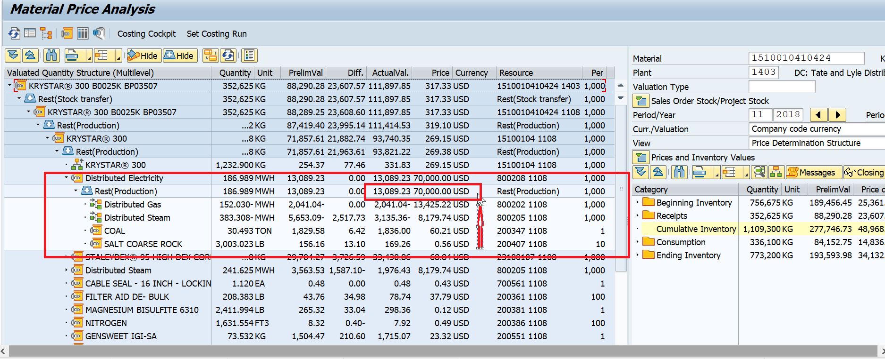

### Z Report Actual Cost Display

1. It is possible to display Actual Cost from lower level component values form CKM3N (Click Shift + 8) for some of the materials.

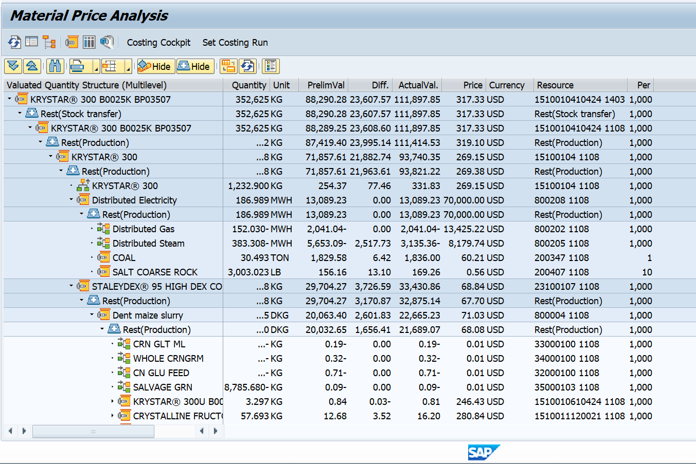

1. Value of Non-Stock items can be arrived at plant level, since it is classified as Price determination V (Moving Average Price). Non-Stock item values will not reflect in CKM3N valuated quantity structure.

1. Fixed Cost can be arrived at Cost Center level. Not possible to display at (BOM level) component of quantity structure or.

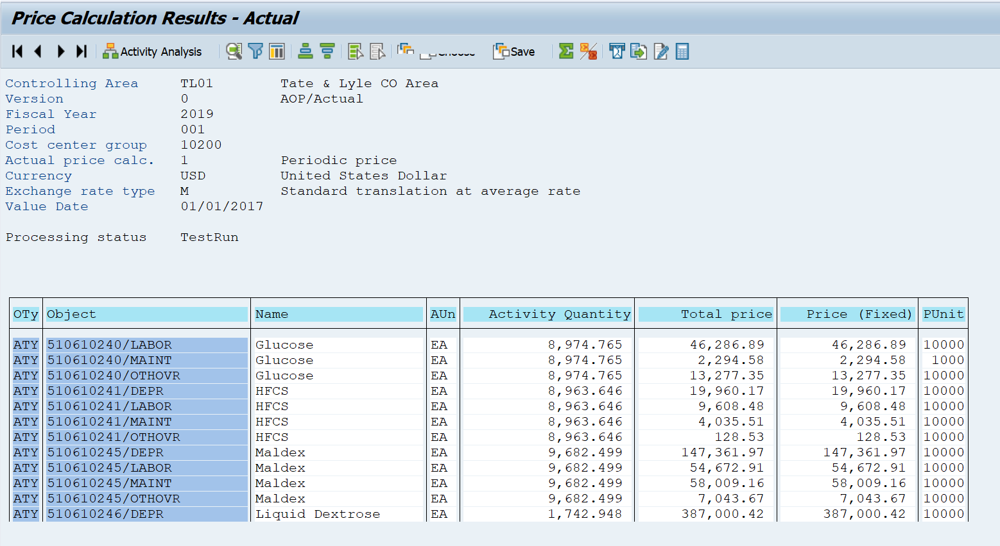

1. Cost directly posted through FI entries can be arrived from BSEG table but it is not possible to display exact apportioned values as actual cost for the component quantity structure (BOM Level)
2. Any other cost posted during period end close (Assessment, Order settlements Etc.) can be arrived but it is not possible to display exact apportioned values as actual cost for a component quantity structure (BOM Level)

## Conclusion

After doing the analysis Wipro team concluded that, it is not possible to develop a Z program in SAP ECC for developing a report with Actual Cost of Exploded Quantity Structure for all exploded BOM items. The reason being SAP architecture is not supporting actual cost for all exploded items for a quantity structure. Reference - SAP Notes 1884961, 1004597. Screenshots of SAP notes are provided in this document.

## Assumption

SOR – Statement of Requirement

BOM- Bill of Materials